INFLUENCE OF DATA AND INTERPOLATOR SELECTION FOR MAPPING THE RAIN DISTRIBUTION PATTERN IN THE BABITONGA BAY REGION, SOUTHERN BRAZIL
Fabiano A. Oliveira – University of Joinville
fabiano.oliveira@univille.net

Introduction
The Babitonga bay is a estuarine system located on the border of the Serra do Mar mountain range, which runs along part of the brazilian southeastern and southern coast. The surrounding area of the bay is formed mainly by 3 different environments: the coastal plain, the scarps of the Serra do Mar and the Atlantic Plateau, with an altitude variation from the sea level to 1520m over a straight line distance of less than 12km (figure 1). The research area consists of a 742 km² polygon situated on the western border of the bay, formed by 10 different hydrographic basins. The variety of topographic features found in the area has strong influence in the rain distribution pattern, mostly influenced by orographic rain (figure 2).

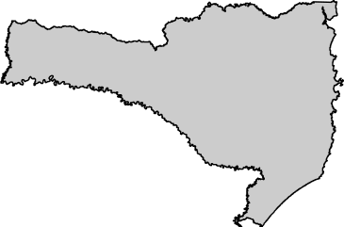
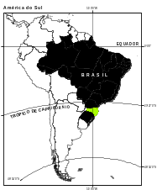
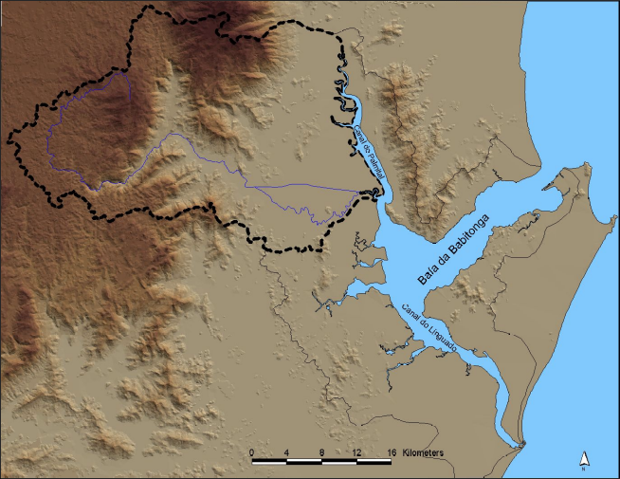

Figure 1: Location of the research area

The lack of rain distribution maps of the region in scales larger than 1:1.000.000 constitute a hindrance for environmental studies. The available maps indicate a rain distribution gradient, but it’s limits seem to be far from the observed field reality.

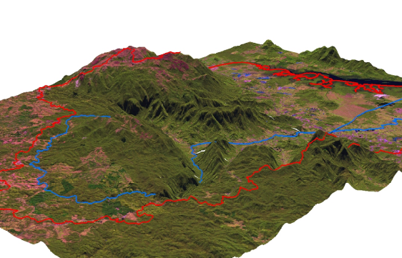
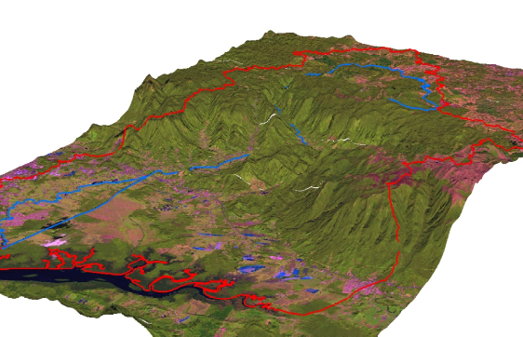

Figure 2: Views of the research area (in red) from SW-NE (left) and NE-SW (right) indicating a variety of topographic features, which influence the orographic rain.

Precipitation Data

The precipitation data used to accomplish a more precise 1:50.000 scale precipitation map were obtained in a 65-year historical series from 22 different climatologic stations surrounding the research area (figure 3), available in the Hidroweb service from the Brazilian National Water Agency.
It’s important to remember that these stations were, however, not simultaneously active throughout the years. The statistical means of each station may thus reflect distinct climatic realities, or episodes, and not the linear evolution of the whole period.
According to the statistical means, the stations can be grouped into precipitation bands, which vary according to their location in the plateau (1400-1600mm), in the scarpments (1800-2300mm), close to the scarpments (2.300-3.000mm) ande in the coastal plain (1.500-2.400mm). It’s possible to notice a pluviometric gradient from east to west between the coastal plain and the highland areas, with a more intense precipitation in the lower areas close to the scarpments.
A closer analysis of the statistical means showed that the data of some stations did not reflect the regional precipitation pattern, with much lower values than expected. Within a universe of 462 annual values, 13 referred to means under 1000mm. These were discharged as outliers.

Figure 3: Location of the 22 climatologic stations .

Precipitation Map

The DEM generated in the ArcMap 8.1 from the official cartographic base was used as base for interpolation procedures in the same software. According to Goodchild & Kemp (1990), some researchers value the manual interpolation procedures (eyeballing), which can detect abrupt variations as well as consider the particular characteristics of the area to be modeled through the individual knowledge of the professional that accomplishes the procedure.
The preoccupation to define an adequate interpolation procedure is based in the fact that the research area has a significant topographic gradient, thus subject to a differentiation in the rain distribution pattern due to relief conditioning. Field knowledge is hence fundamental to a criticism to automatic statistical analysis and interpolation procedures in a GIS environment.
The interpolation procedures were made in the Geostatistical Analyst module of the ArcMap 8.1 software. This module offers a wide range of interpolators, divided into two main groups, the deterministic and the geostatistic, which relate to deterministic and stochastic interpolation procedures.
According to ESRI (2001), the deterministic procedures create surfaces from the effectively measured points based either on the extension of similarity (Inverse Distance Weighted method) or on the softness level (Radial Basis Functions method). The deterministic procedures can also be divided into two groups, the global (Global Polynomial) and the more accurate local interpolators (Local Polynomial, Inverse Distance Weighted and Radial Basis Functions) (1st, 2nd and 3rd degree polynomial).
The geostatistic procedures (or stochastic), according to ESRI (2001) create surfaces that incorporate the statistic properties of the measured data. The ArcMap 8.1 offers a wide range of methods associated to geostatistical procedures, all related to Kriging: ordinary, simple, universal, probabilistic, indicative, disjunctive. The kriging methods represent exact interpolators that rely on the notion of autocorrelation, that, on the other side, is function of the distance. Compared to other methods, kriging demands frequent decision making during the interpolation procedure, as it offers a wider range of options to be considered and controlled. Each option yields to significant changes, among them the anisotropy and the nugget effect.
In the first stage of the interpolation, the general statistical means of pluviometric data were investigated according to their distribution in histograms and Voronoi polygons (figures 4 - 5). The histograms indicated a small difference in the in the general precipitation mean values and mean values without the outliers, or smaller than 1000mm (figure 4). A preliminary evaluation based on the Voronoi polygons showed that the withdrawal of the outlier values, or statistical means under 1000mm, produced a small alteration in its spatial distribution. This preliminary mapping allowed a first view of the precipitation data geometric distribution pattern, with higher values concentrated along the SW-NE axis (figure 5).

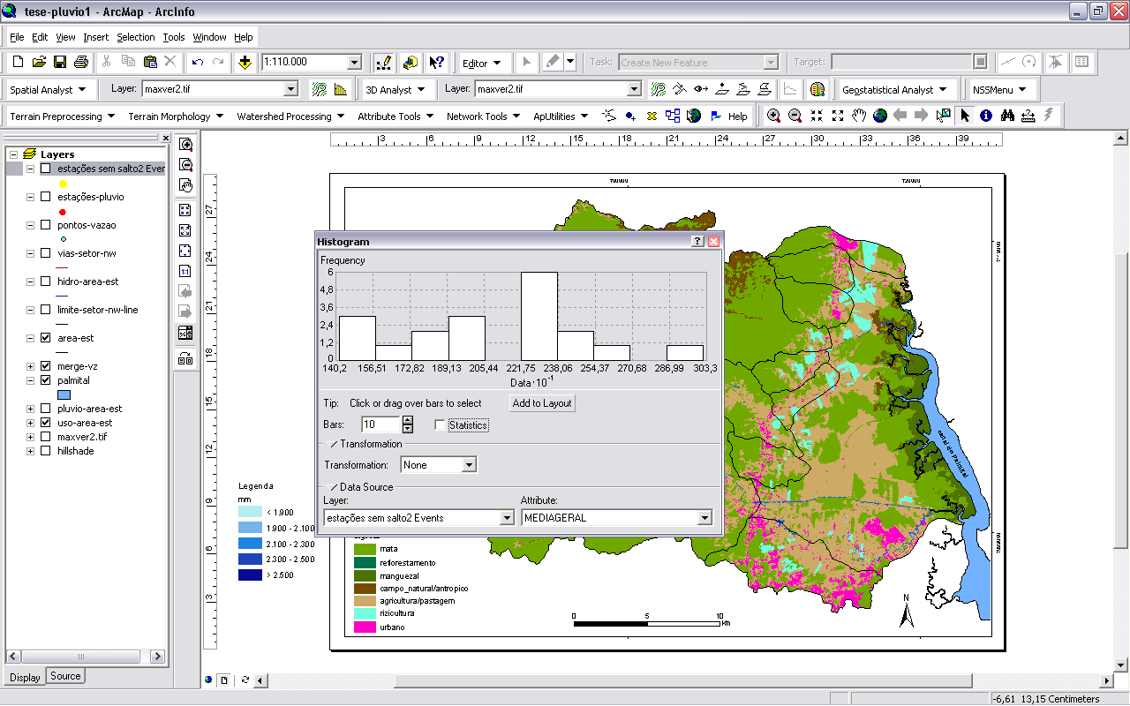
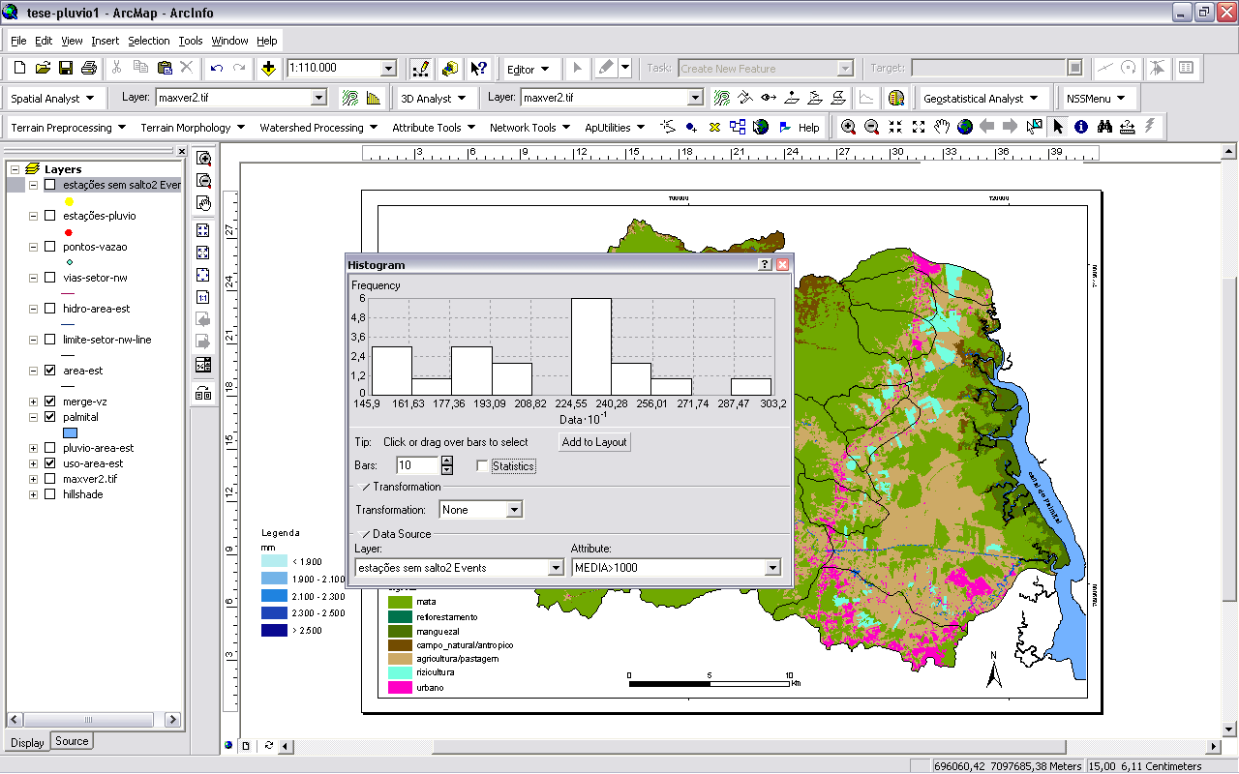

Figure 4: Histograms indicating diferences in the general precipitation mean values (left) and mean values without the outliers, or smaller than 1000mm (right).

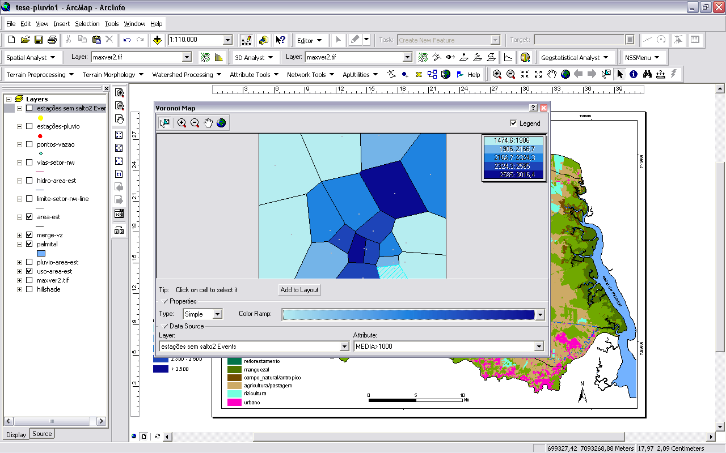
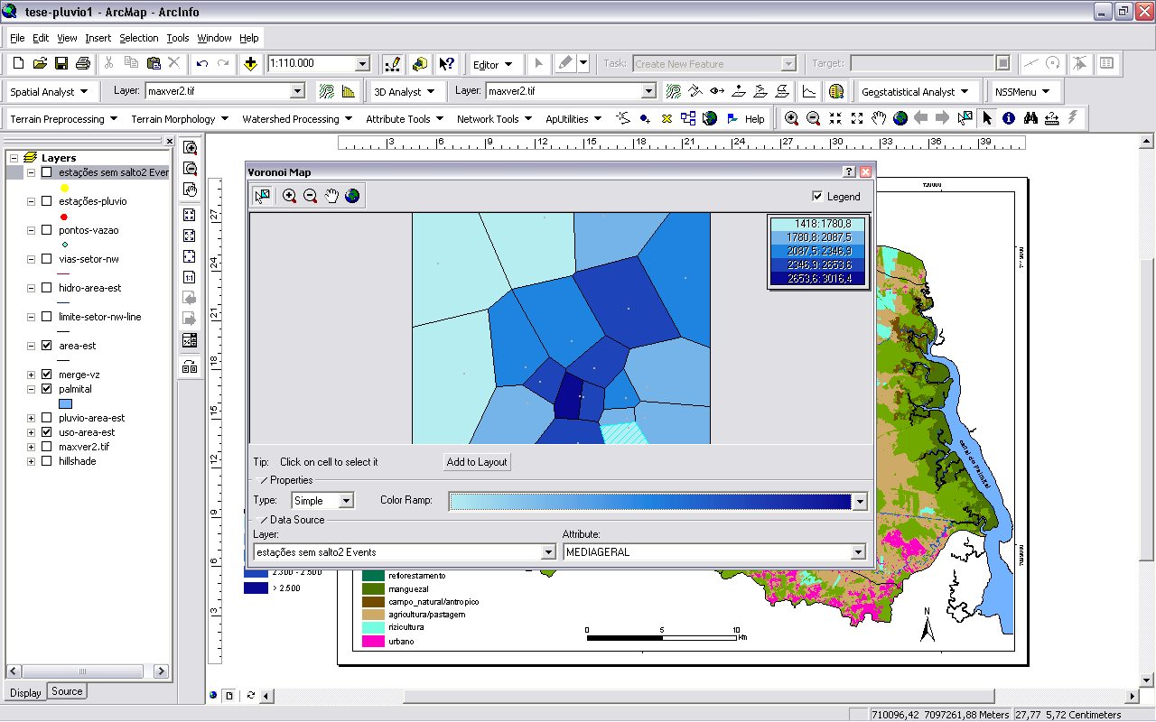

Figure 5: Voronoi polygons indicating differences in the spatial distribution of general precipitation mean values (left) and mean values without the outliers, or smaller than 1000mm (right).

Interpolation tests were made with the methods offered by the software, including either the general statistical means with all values or the means which included only values above 1000mm. There were made also tests including and excluding the climatologic stations named Quiriri-CCJ and Salto 2.
The withdrawal of both stations resulted in much better defined maps, as it was previously identified in the statistical analysis that there was a clear discrepancy between their precipitation data and the data from the whole set of stations.
The tests originated in 90 different maps (figure 6). Local and Global Polynomial interpolators produced similar maps that reflected the tendency or rain distribution pattern previously observed in field work. The resulting bands were, however, too broad and did not mirror effectively the concentrated orographic rains that occur in the scarpments. Other maps, specially those containing the data from the Quiriri-CCJ and Salto 2 stations were so far from reality that could not be considered.

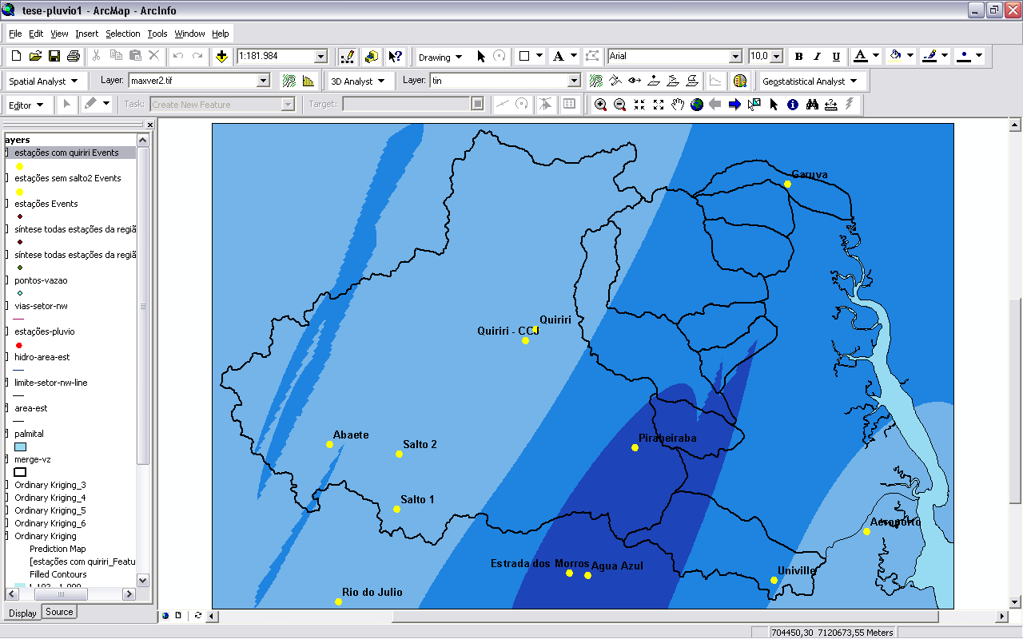
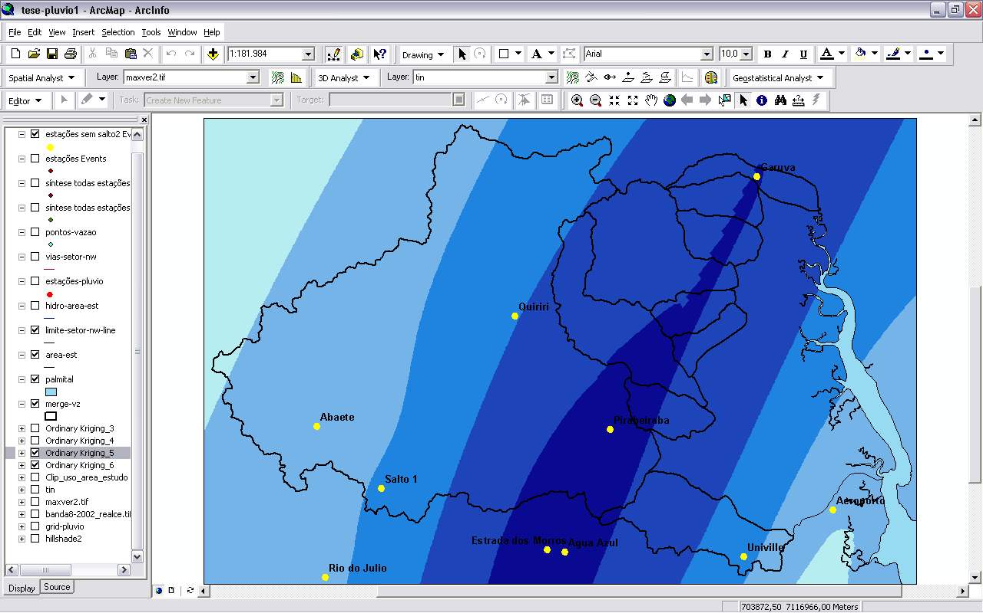
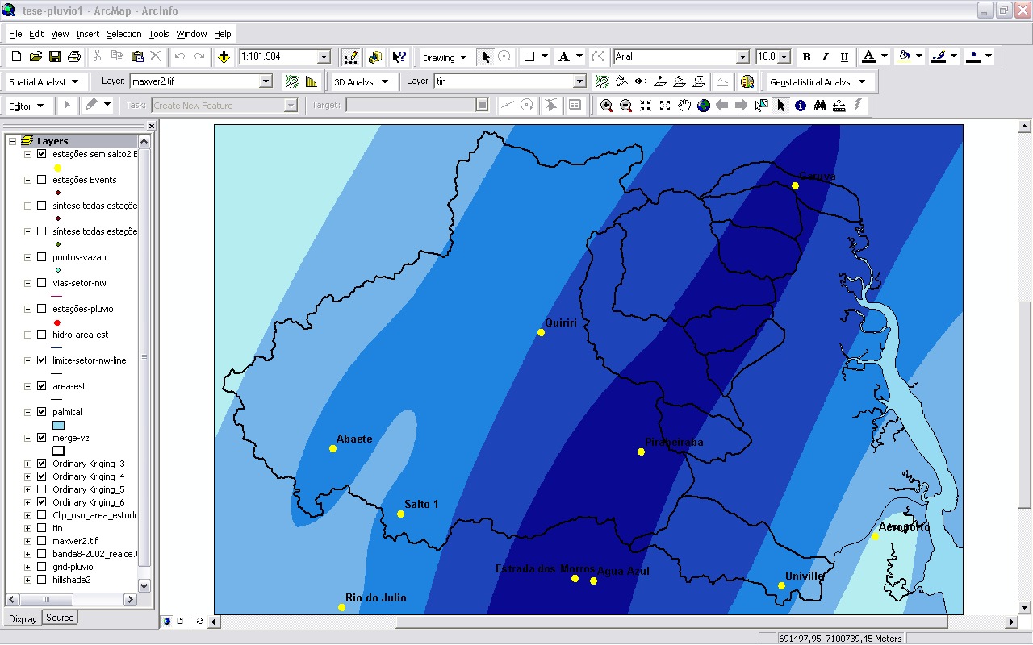
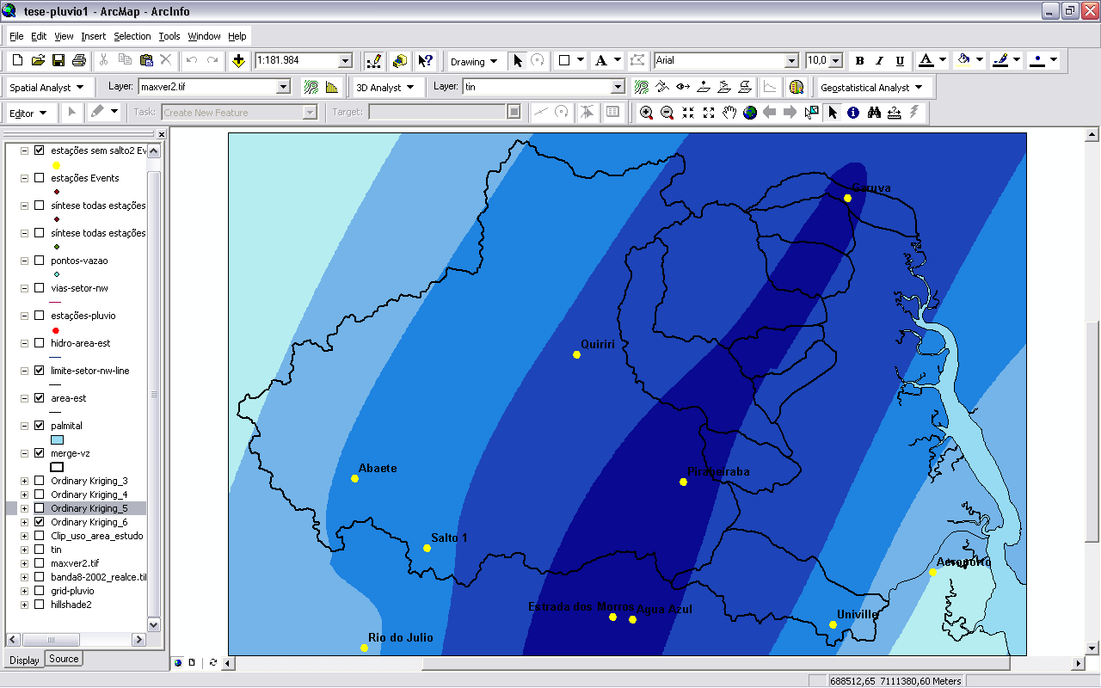
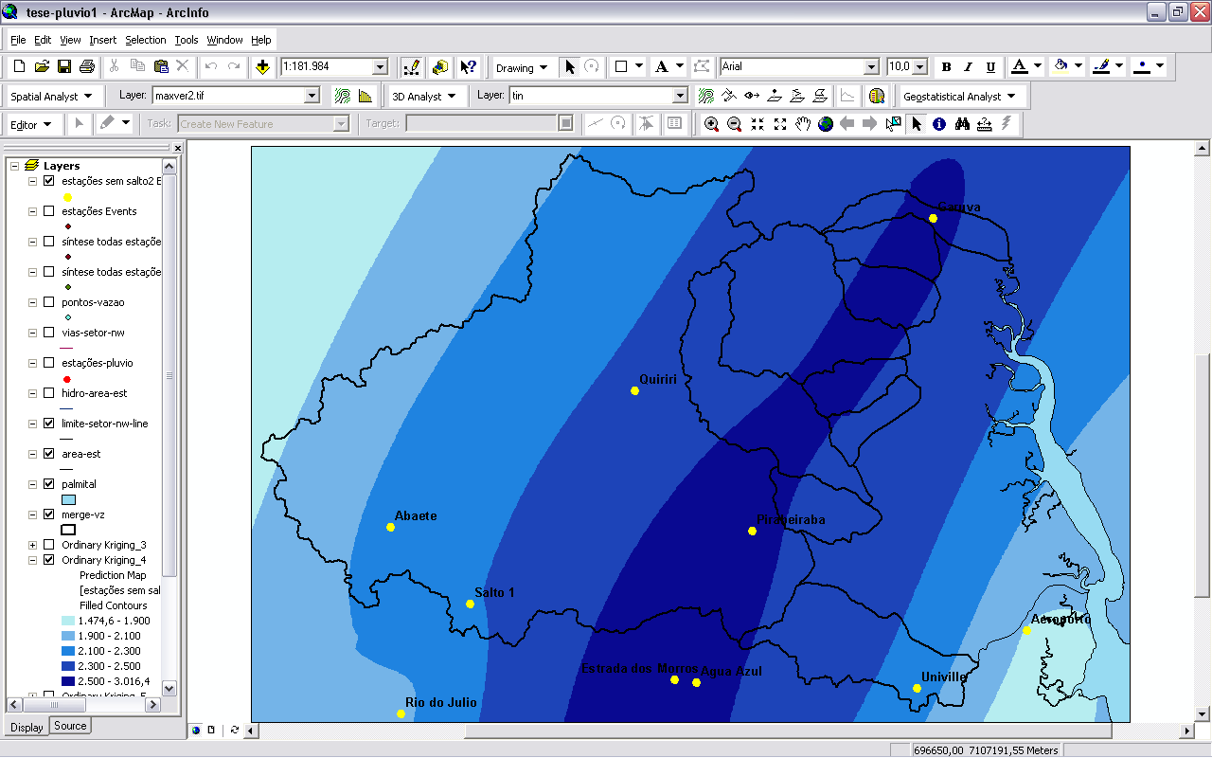
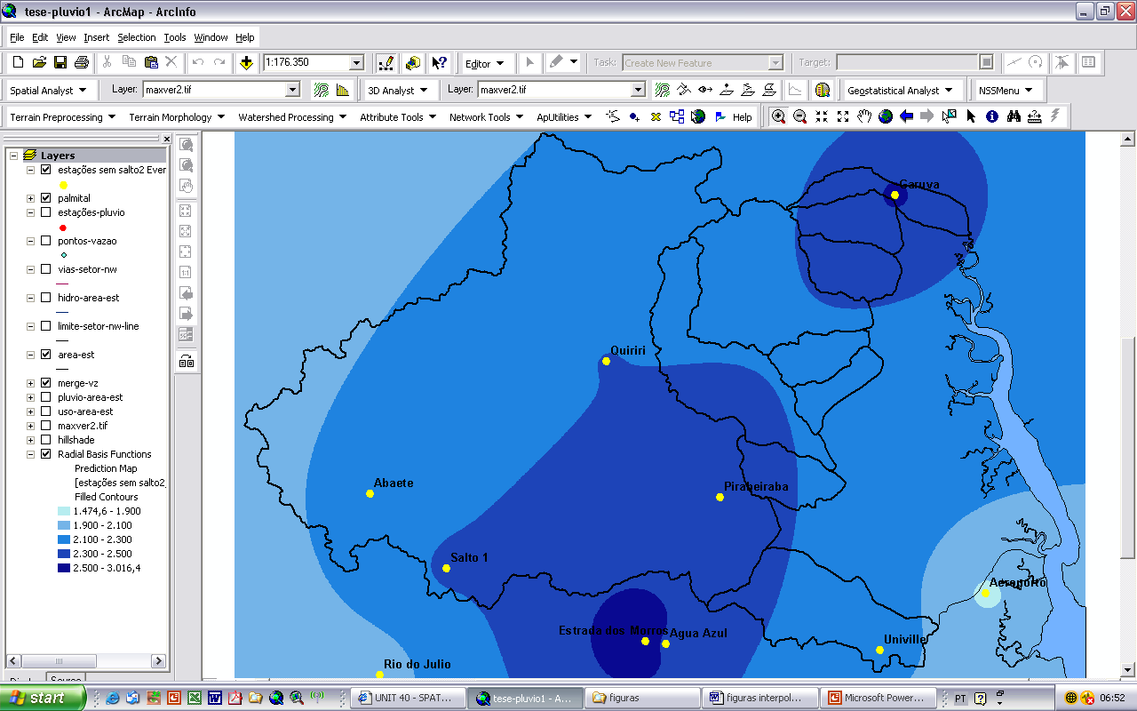
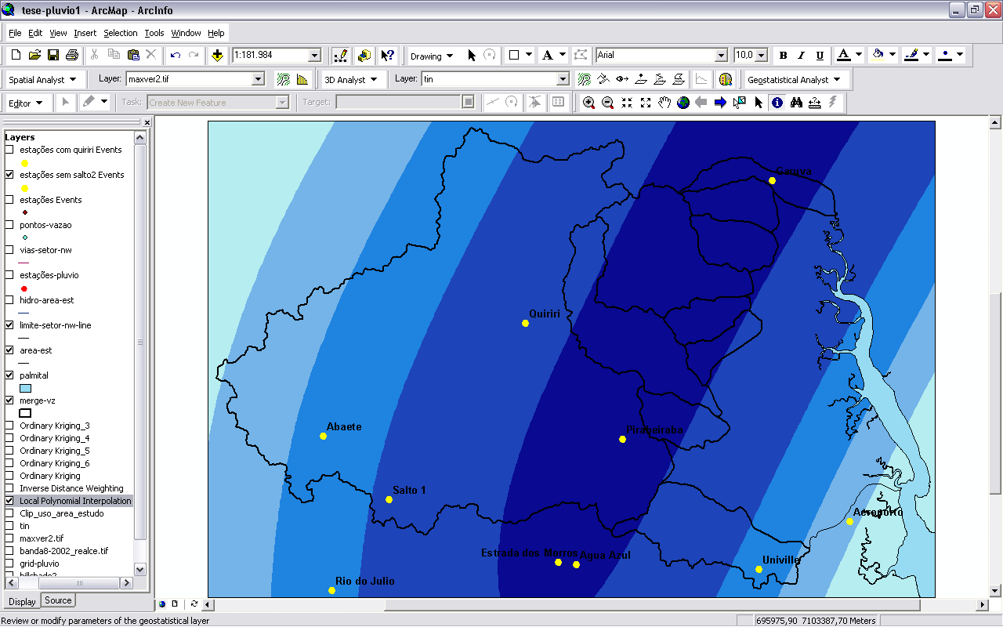
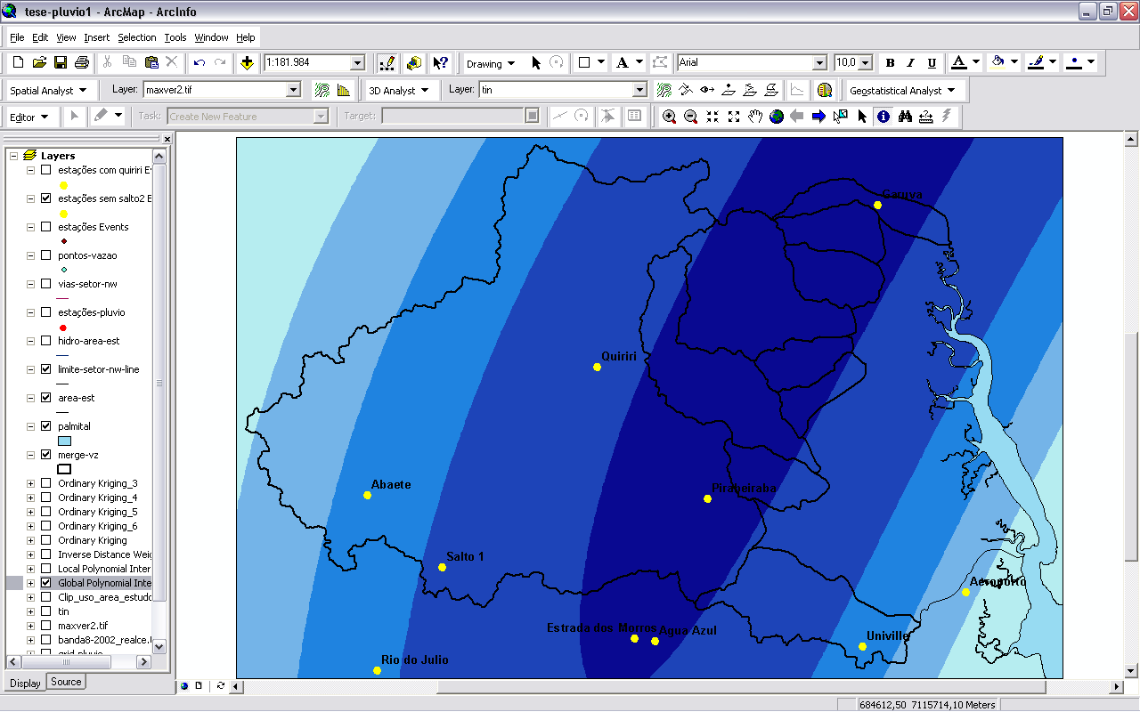
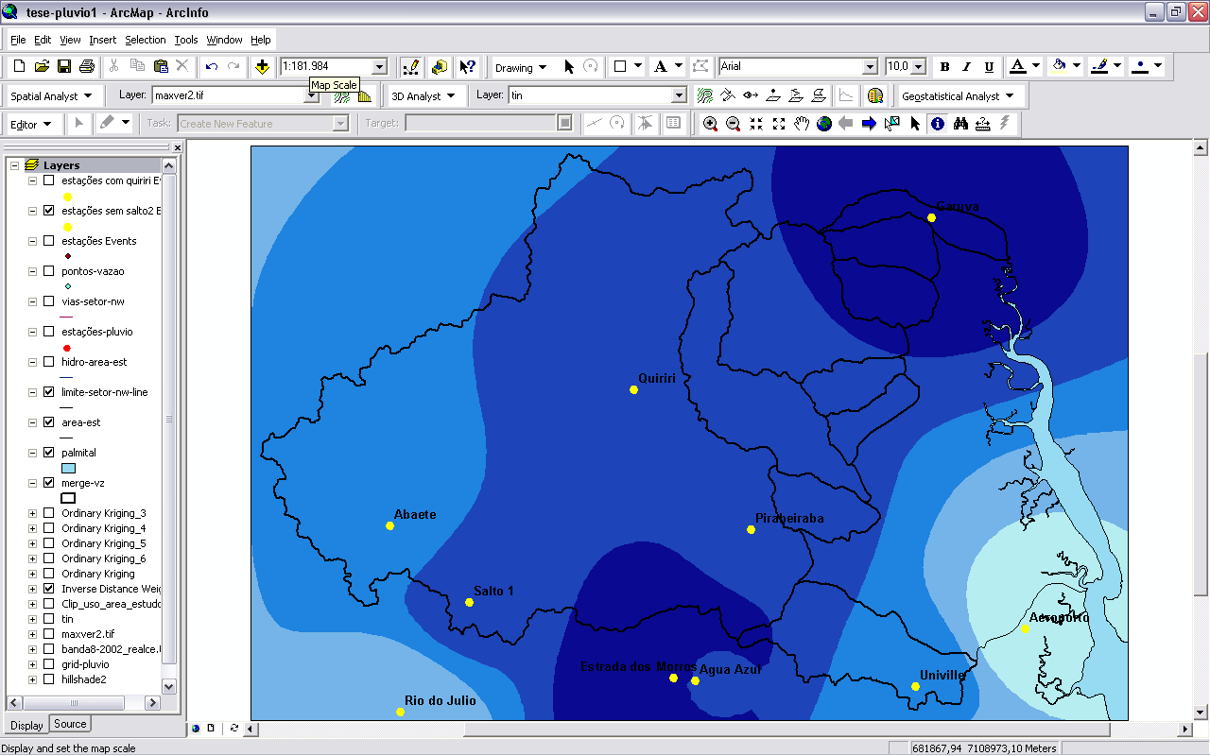
1
2
3
4
5
6
7
8
9
1 Kriging: general mean with Salto 2 e Quiriri-CCJ

2 Kriging: general mean with Salto 2, without Quiriri CCJ

3 Kriging: mean >1000mm with Salto 2, without Quiriri CCJ

4 Kriging: general mean without Salto 2, without Quiriri CCJ

5 Kriging: mean >1000mm without Salto 2, without Quiriri CCJ

6 Radial Basis Functions: mean > 1000 without Salto 2, without Quiriri CCJ
7 Local Polynomial (3rd degree): mean > 1000 without Salto 2, without Quiriri CCJ

8 Global Polynomial (3rd degree): mean > 1000 without Salto 2, without Quiriri CCJ

9 Inverse Distance Weighting: mean > 1000 without Salto 2, without Quiriri CCJ

mm
1.900 - 2.100
2.100 - 2.300
2.300 - 2.500
> 2.500
< 1.900

Figure 6: Selection of precipitaion maps built from tests with different interpolators in distinct situations, containing all annual statistical means or only the means with values above 1000mm. Including or excludind the Quiriri-CCJ and Salto 2 stations. The width and the reach of the precipitation bands vary significantly.

Kriging was the most sensitive method to data variation (figure 6, nr. 1-5) and resulted in a more defined and close to field reality map (figure 6, nr.5; figure 7). The chosen map shows adequatly the general SW-NE axis of rain distribution along the scapments, what is consistent with the prevailing SE/S winds that bring humidity from the Atlantic Ocean.

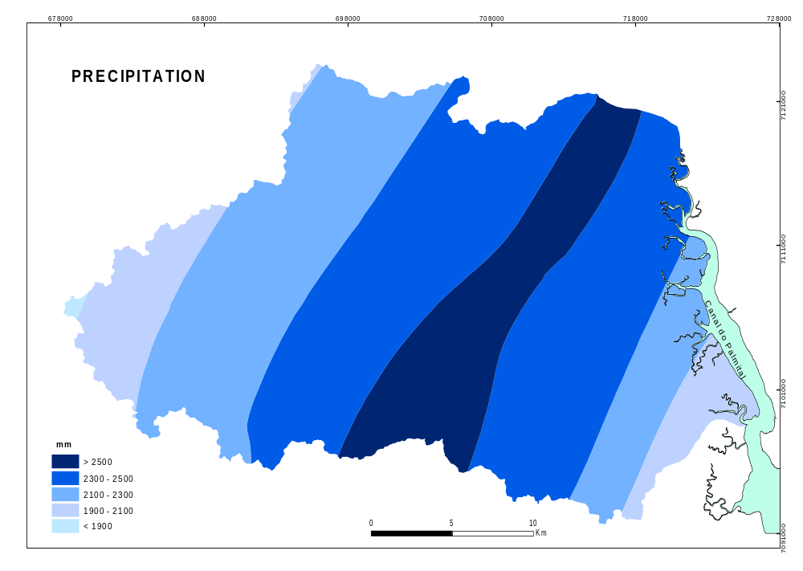
Figure 7: Final precipitation map

Final Remarks

Results showed that small differences in data input with the same interpolator may result in significant variations of the rainfall contour lines. On the other hand, the use of the same set of data with different interpolators resulted also in distinct map drawing. The final map obtained with ordinary kriging makes evident the importance of field knowledge to guide the decision making process during the interpolation procedures in a GIS environment.

References

ANA – AGÊNCIA NACIONAL DE ÁGUAS. Sistema de Informações Hidrológicas – HidroWeb. http://hidroweb.ana.gov.br/. Access on 7/13/2006.

ESRI, 2001. Using ArcGIS Geostatistical Analyst – GIS by ESRI. Redlands, ESRI.

GOODCHILD, M.F.; KEMP K.K., 1990. NCGIA Core Curriculum in GIS.
National Center for Geographic Information and Analysis, University of California, Santa Barbara CA. http://www.geog.ubc.ca/courses/klink/gis.notes/ncgia/u40.html. Access on 7/29/2006.

ANA – AGÊNCIA NACIONAL DE ÁGUAS. Sistema de Informações Hidrológicas – HidroWeb.

